Create Linked Service to connect to Azure SQLDB
1.Login to the Azure Data Factory
2.Go to Manage and click on +New, Select Azure
3.Select Azure SQL Databases
4.Assign name to Linked Service
5. Provide the necessary details:
- Name: AzureSQLClinicalResearchDB_LS
- Connect via integration runtime: AutoResolveIntegrationRuntime
- Server name: clinicalresearchsqlserver
- Database name: ClinicalResearchDB
- Authentication method: Choose SQL Authentication
- Username/Password: If using SQL Authentication, enter the SQL Server credentials.
- You need to Test Connection
6. Test connection to ensure that Data Factory can connect to the Azure SQL Database.
7. Create the linked service.
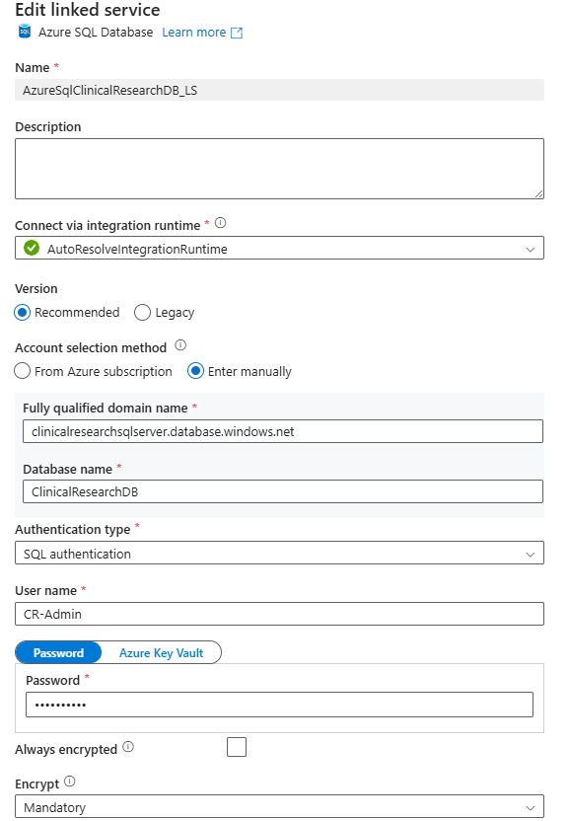
Create Linked Service to connect to Blob Storage
1. Login to the Azure Data Factory
2.Go to Manage and click on +New, Select Azure
3.Select Blob Storage
4. Provide the necessary details:
Name: ClinicalResearchSA_LS
Description: Linked Service for connecting to Azure Blob Storage
Connect via integration runtime: AutoResolveIntegrationRuntime
Authentication method: Account key
Subscription: Enter Manually
Storage account name: clinicalresearchsas
5. Test connection to ensure that Data Factory can connect to the Blob Storage account successfully.
6.. Create the linked service.

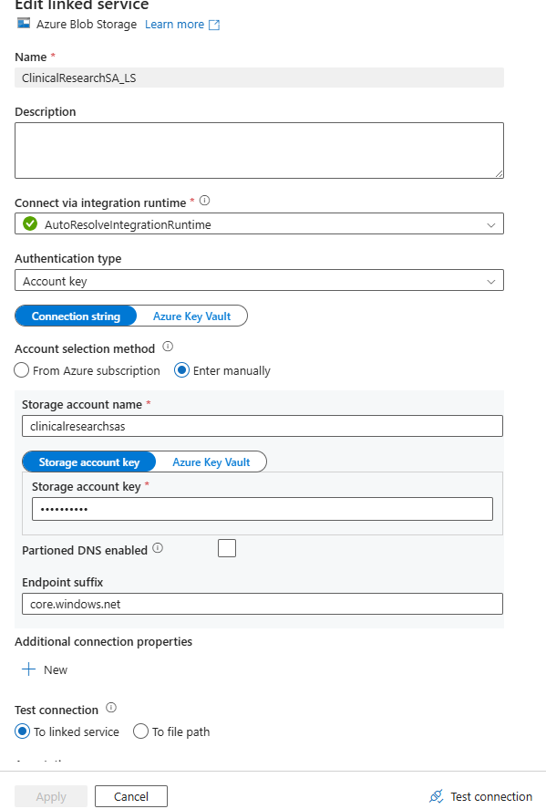

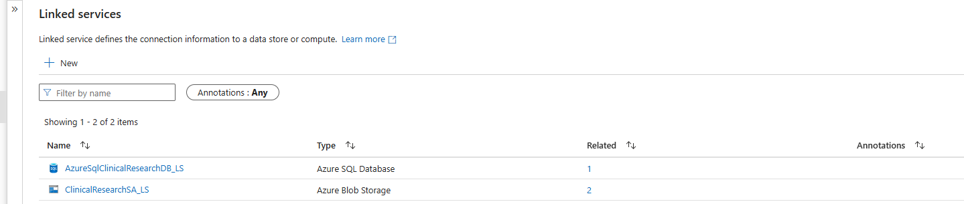

Create dataset to connect to blob within blob .CSV to ADF
1. Login to the Azure Data Factory
2.Go to Manage and click on +New, Select Azure
3. Go to Author, under Factory resources click on dataset actions
4.Select New Dataset
5. Select Azure
6.Select Blob Storage, select format
Dataset Name: Blob_Dept
Linked Service: ClinicalResearchSA_LS
File Path:
- File: data/example.csv
- Format: DelimitedText
- Column delimiter: , (comma, the file is CSV format)
- First row as header: Enabled (if the file has a header row)
7.Click on Ok
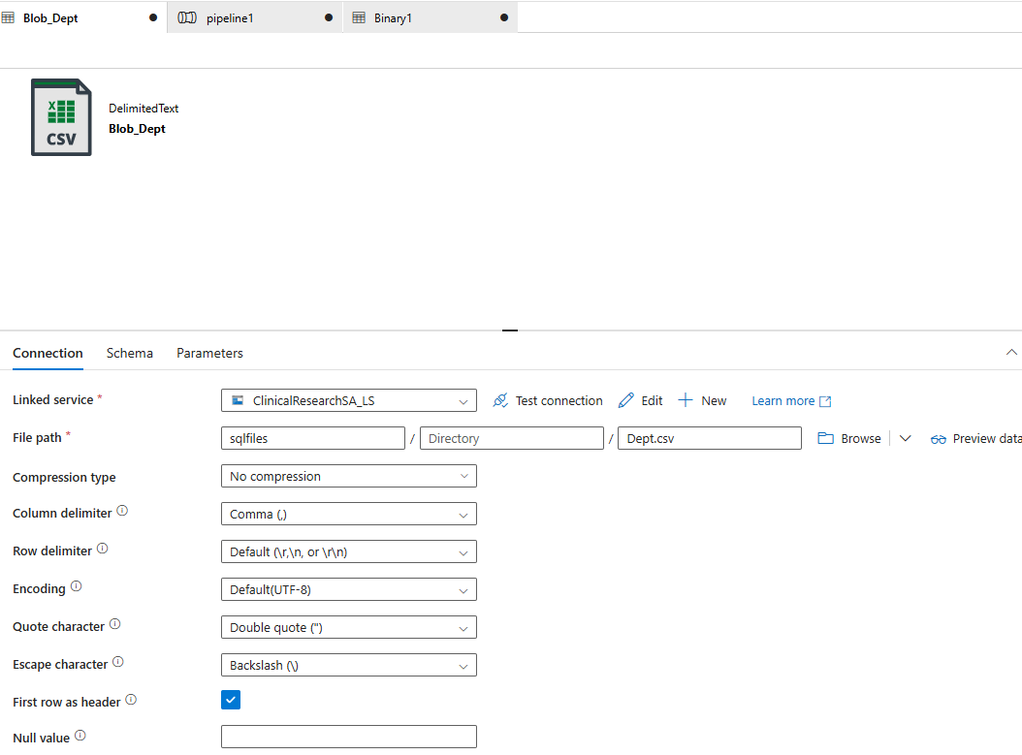

Create Pipeline to connect to SQL Database within blob .CSV to ADF
1. Login to the Azure Data Factory
2.Go to Manage and click on +New, Select Azure
3. Go to Author, under Factory resources click on Pipeline … select New Pipeline
4.Click on Activities and expand Activities and Drag and drop copy data to the canvas
5.Select Source and select Source Dataset Blob_Dept
6.Select Sink, sink dataset you need to create click on +New
7. Select Azure
8.Select SQL Database
- Dataset Name: AzSQL_Dept
- Linked Service: ClinicalResearchSA_LS
- Table Name: Dbo.Dept
- Select Enter manually
- Import Schema: None
9.Click on Ok
10.Click on Sink and select Table option Auto Create Table
11. Validate and validate run time and Debug. successfully Pipeline created and go to the ClinicalResearchDB and Go to the Query Editor and enter Credentials and Under Table you can find dbo.Dept Table.

